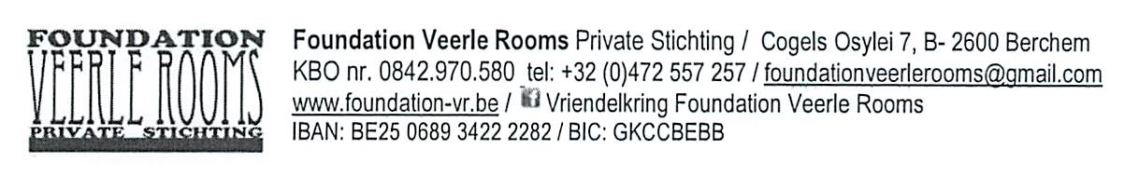

Application Form Artist in Residence Foundation VR
__________________________________

1. Contact information

Personal details

First name:
Name:
○ Male ○ Female
Date of birth: (dd/mm/yyyy)
Nationality:
Facebook: (a link to your facebook profile)
Website:
Social security number: (personal number in your country's social security system)
Passport number:
Passport photo: (1 file / jpg or png / max. 2MB and 2000 x 2000 pixels)

Contact

Telephone: (international nr, starting with +)
Mobile: (international nr, starting with +)
E-mail:
Address:
Postal code:
City:
Country:
Contact language :

2. General residency

During min. ........ weeks a professional artist or graphic designer realizes a project, which corresponds with his or her own artistic practice. Experience with the graphic medium is not required, although every resident has to be able to realize his or her project independently. A member of the technical staff is available for advice or help.

Period: …………………………………………….20…………
1st choice: start: (dd/mm/yyyy)
1st choice: end: (dd/mm/yyyy)
2nd choice: start (optional): (dd/mm/yyyy)
2nd choice: end (optional): (dd/mm/yyyy)

3. Artistic project description

The project you wish to realize during your residence is related to your artistic practice. In the description, you clearly state what added value the graphical techniques give to your project, and how the medium fits into your artistic concept. Your project is contemporary and relevant.

Project description
(jpg or png / minimum 7 — maximum 12 photos / max. 2MB and max. 2000 x 2000 pixels each)
Give a short content description of the project you wish to realize during your residence.
Characters left: 2500
Added value of the graphical techniques for the content of your work.
Give a short motivation why the graphical techniques are the chosen medium to realize your project.
Characters left: 1000
Artist statement
Give a description of your artistic work.
Characters left: 2500
Minimum 7 – 12 photos / Max 2 MB jpg.

4. General conditions

Costs
Artist in residence costs 45 €/day, 200€ /week or 300€/week including use of the studio
As you are a researcher - staying for a longer period - we can offer you your residence at the lowest cost

