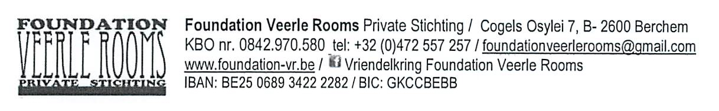

FOUNDATION VEERLE ROOMS / Convenant Artists in Residence

Chapter I : Objective

Article 1: It is the main statutary objective of the Foundation Veerle Rooms (FVR) to promote printmaking arts and its practitioners in the widest sense of the word. Organizing exhibitions, lectures, workshops and studio visits are the scope, and also facilitating these, by organizing an ‘Artist in Residence’ (AiR). This list is not exhaustive.

Article 2: On a regular basis the FVR will organize an AiR for Belgian and international residents, within its logistic, administrative and budgettary capacity. These artists and / or researchers work actively in the printmaking arts, in a technical or scientific manner. Candidates with a traineeship can also be taken into consideration.

Article 3: The FVR organizes its AiR in the framework of mutual cooperation. The FVR facilitates the accommodation and work and exhibition circumstances for the resident. The resident for his part will deliver a certain performance, by mutual agreement.

Chapter II : Responsibilities of the FVR

Article 4: The FVR provides a studio to accommodate a maximum of 2 persons, in the seat of its organization - address: Cogels Osylei 7 in B-2600 Berchem - or in case it is unavailable, at a friendly partner’s address

Article 5: The FVR provides a printmaking studio the resident can use according to the agreed terms, under the guidance of a person responsible appointed by the FVR, or on his own.
Address: Cogels Osylei 7 in B-2600 Berchem or in case this studio is unavailable, at a friendly partner’s address.

Article 6: The FVR puts its network to the disposal of the resident, in order to enable contacts with artists or institutions in Antwerp and the surrounding area, or to facilitate a limited exhibition.

Article 7: The FVR restricts itself to organizing 2 AiR a year: between April 1st and June 30th and between September 1st and November 30th. The duration and period are always determined well in advance with the above-mentioned person responsible.

Chapter III : Responsibilities of the resident

Article 8: The resident is at least 18 years old at the moment of the residence and is experienced in the independent use of a printmaking studio as artist or teacher. The residents can also be accepted as candidates / printmakers in a traineeship.

Article 9: The resident is responsible for his / her transportation to the AiR accommodation.
The residents are staying on a basis of self-catering. A “welcome package” will be provided.

Article 10: The resident bears the expenses of the material he / she needs for the work in the studio or for the buildup of the exhibition. However the FVR could help bargain over the prices / rent at local suppliers.

Artikel11: The FVR organizes its AiR in the framework of mutual cooperation. The FVR facilitates the accommodation, work and exhibition circumstances for the resident.
- The resident will donate in return, in consideration with the FVR, prints that were created during the AiR or prints from his / her own property.
- If the resident does NOT donate an artistic compensation, he / she will be charged a higher accommodation fee.

Article 12: The resident will bear all responsibility for moral and material damage caused during his / her AiR stay and will take out his / her own insurance policy of third-party liability.

Chapter IV : Administrative agreements

Article 13: The resident or his / her principal will bear the expenses of the AiR stay, unless a different decision was made in advance by the Board of the FVR.
He / she will provide his / her own necessary documents and permits to reside or work in Belgium. The FVR can – upon agreement – provide an official invitation to the residence. (f.i. to apply for a visa).

Artikel 14: According to the nature of the agreement for an AiR stay 3 accommodation fees are possible:
- An AiR stay WITHOUT use of the studio costs 60 €/day, 300 €/week or 950€/month;
- An AiR stay WITH use of the studio but WITHOUT an artistic compensation of the resident costs 65 €/day, 350 €/week or 1050€/month;
- An AiR stay WITH use of the studio and WITH an artistic compensation of the resident costs 55 €/day, 250 €/week or 850€/month;
Weekly cleaning of bed linen and towels is included.

Artikel 15: During the stay the FVR facilitates work and exhibition circumstances for the resident.
- Following these facilities the resident will donate the FVR 10% of his / her sales figure;
- The FVR itself will vouch for the organization of the exhibitions and/or workshops in favour of the resident and will recover the income of these activities. In exchange the FVR will pay the resident an agreed fee.

Article 16: Each stay as AiR must be requested by the applicant or his / her principal at least 6 months in advance through the secretariat of the FVR.
This means before October 1st (for a residence in April / June) and before March 1st (for a residence in September / November).

Article 17: The FVR Board alone is authorized to allow deviations to his covenant. The correspondence and agreements can only be ratified by the FVR chairman or his representative.

Application – Information

foundationveerlerooms@gmail.com

http://www.foundation-vr.be

Are you interested?
Please apply immediately in writing or by e-mail to the above mentioned address with the following data:

Name and first name:
Nationality:
Date of birth:
Address:
Phone number:
E-mail address:
Curriculum vitae:
Motivation for your application:
Desired period of your stay:

